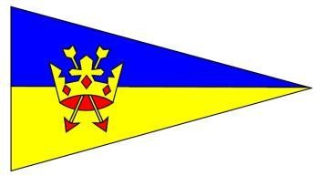

WALDRINGFIELD SAILING CLUB

**NOTICE OF RACE ILCA/LASER OPEN MEETING**

**Sunday 27th April 2025**

**4 Races for ILCA 4, 6 & 7**

Entry fee £12

Online entry until 2345hrs 25th April

**Briefing 10.30am First start at 11:15**

**High water 12:57**

**Replica sails and equipment will be permitted.**

**Subject to the Race Officer’s discretion the intention is to have 2 races before lunch and 2 after, weather permitting.**

**All rigs to start together. Results will be position over the line with rigs displayed in results table. Prizes will be given for best in class.**