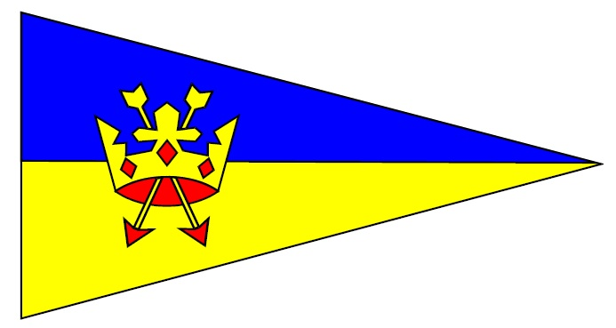
Waldringfield Sailing Club

Notice Of Race
Cartoon Trophy Open Meeting
at Waldringfield Sailing Club, River Deben, Suffolk IP12 4QL
Saturday 12th and Sunday 13th September 2026
Racing for the following classes:
RS200 – Cadet – Dragonfly-Wayfarer – Lark - ILCA
Squib – Topper – OK
Programme
Saturday 12th September 2026 |  |  | Sunday 13th September 2026
HW 1350 |  |  | HW 1425
Points race 1 | Points race 2 | Points race 3 | Points race 4 | Points race 5 | Points race 6
12.00 | TBA | TBA | 11.00 | TBA | TBA

Briefing at 11.00 on Saturday 12th September 2026
The order of starting will be announced at the briefing on the day.
Classes will start at 3 minutes intervals from the times shown above, using the code flags as below. For smaller fleets (fewer than 6 boats), the organiser reserves the right to combine more than one class. All races will be run back-to-back unless otherwise notified on the day, and may start in a different order after the first race of the day. Races may be cancelled at the organiser’s discretion.
CLASS | CODE FLAG
Squib | Naval Numeral 9
Lark | Lark flag (black “L” in yellow background)
RS200 | RS200 insignia on pink background
Wayfarer | Wayfarer insignia (red “W” on white background)
ILCA (all rigs) | Laser insignia (white ILCA symbol on red)
OK | Flag H
Cadet | Flag Y
Topper | Flag T
Dragonfly | Flag W

Note: ILCA and Topper Classes may use replica sails and equipment. ILCA and Topper Classes may swap rigs during the event, with all results being combined for a boat’s overall position, but there will be no handicap or starting concession for smaller rigs.

Entry fee: £10 for Cadets and single-handers and £20 for other classes.
Online entry via https://waldringfieldsc.com/. Entries close 23.45 on 11th September 2026.
General instructions
Waldringfield Sailing Club is the organising authority.
1. Rules
All races will be governed by the Racing Rules of Sailing 2025-2028 (RRS), the prescriptions of the RYA, the RYA Racing Charter principles and objectives, and class rules, except as any of these are changed by the Sailing Instructions. The Sailing Instructions alter RRS 26 Warning/Preparatory signals, 29.2 General Recalls, 35 Time Limits, 40 Personal Buoyancy, 44.3 Scoring Penalties, 46 Person in charge. The Sailing Instructions detail the changes and will be available online and from race reception.
2. Scoring System
The series will be scored as provided in RRS Appendix A, A4.1 Low Points System. If 4, 5 or 6 races are completed, one discard allowed; 3 or fewer completed, all will count. Two races are required to be completed to constitute a series.
3. Trophies
On receipt of a trophy, the trophy winner must sign an acknowledgement of receipt and an agreement to return the trophy to Waldringfield Sailing Club within 1 year and before the start of the next Cartoon Trophy Open Meeting, whichever is sooner. The Trophy must be returned in good condition and engraved with the winner’s details. Failure to return the trophy by that date, or return of a damaged trophy, will incur a penalty of the insured value of the trophy plus £20, payable by the same date.
4. Safety
Adequate personal buoyancy must be worn by all competitors when afloat. Wet suits and non-inflated inflation type buoyancy aids are not sufficient. Keelboats shall carry and listen out on VHF radio Channel 37. It is the responsibility of the parent or guardian of junior members to ensure compliance with this rule. Failure to comply with any safety rule will result in immediate disqualification from the associated race.
5. Membership of Waldringfield Sailing Club
Entrants will become temporary members of Waldringfield Sailing Club for the duration of the event. Attention of members is drawn to club General Rule A3 as follows.
Neither the Club nor its Officers, General Committee (“the committee”), servants, agents or members will accept any liability for:
- damage direct or consequential to or loss of property belonging to members, competitors, their guests or visitors or other persons
- personal injury direct or consequential arising out of the use of Club premises and any other facilities of or used by the Club, whether sustained by members, competitors, guests or visitors, whether or not such damage or injury could have been attributed to or was occasioned by the act, neglect, default or negligence of the Officers, Committee, servants, agents or members of the Club.
Before inviting any guest or visitors onto Club premises or to use Club facilities or to participate in events organised or authorised by the Club, members and competitors will draw their attention to this rule.
6. Risk Statement
Rule 3 of the Racing Rules of Sailing states: “The responsibility for a boat’s decision to participate in a race or to continue racing is hers alone.”
Sailing is by its nature an unpredictable sport and therefore involves an element of risk. By taking part in the event, each competitor agrees and acknowledges that:
- They are aware of the inherent element of risk involved in the sport and accept responsibility for the exposure of themselves, their crew and their boat to such inherent risk whilst taking part in the event;
- They are responsible for the safety of themselves, their crew, their boat and their other property whether afloat or ashore;
- They accept responsibility for any injury, damage or loss to the extent caused by their own actions or omissions;
- Their boat is in good order, equipped to sail in the event and they are fit to participate;
- The provision of a race management team, patrol boats, umpires and other officials and volunteers by the organiser does not relieve them of their own responsibilities;
- The provision of safety boat cover is limited to such assistance, particularly in extreme weather conditions, as can be practically provided in the circumstances;
- Their boat is adequately insured with cover of at least £3,000,000 against third party claims.

Late entries may be accepted at the discretion of the Race Officer with an additional fee of £5 on top of the above entry fees.

